***2D-GAME***

* **INTRODUCTION:**

We have designed a 2D game using the concept of object oriented language (OOP) and also by using SFML which is an external language of C++. We have designed an adventure game where the hero kills the enemy and reach to different levels and gain points. We have created the characters by using Photoshop (pixel version) and have done the animation.

* **PURPOSE:**

The purpose of designing this game was to clear our concept about OOP. To know more about C++ and as this idea was a different one we decided to work on it. Getting to know about Photoshop more and other external Languages like SFML and C++. This was an interesting topic for those who had an interest in game development.

* **LANGUAGE USED:**

The concept of object oriented programming was used and the languages we used were the SFML external language of C++ and other language was C++

* **OTHER OUTLOOK OF 2D-GAME:**
* The startup:

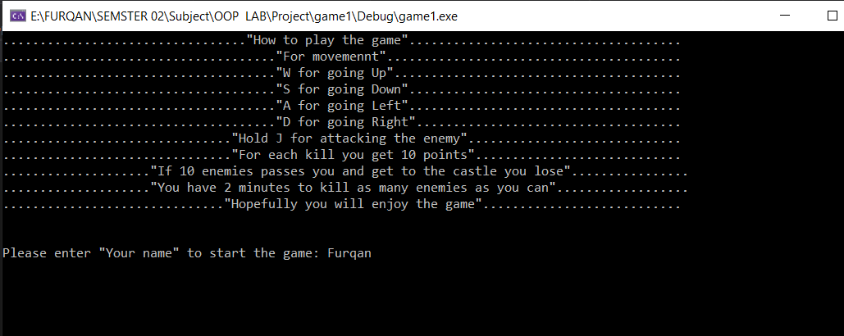

* + At first when the program run the console will open with the game controls mentioned on it. When the user will enter his/her name and press enter the game will start.
  + When the user press enters the game will start and a new window will open with hero and enemy’s animation as well as the animation of health and time animation.
* 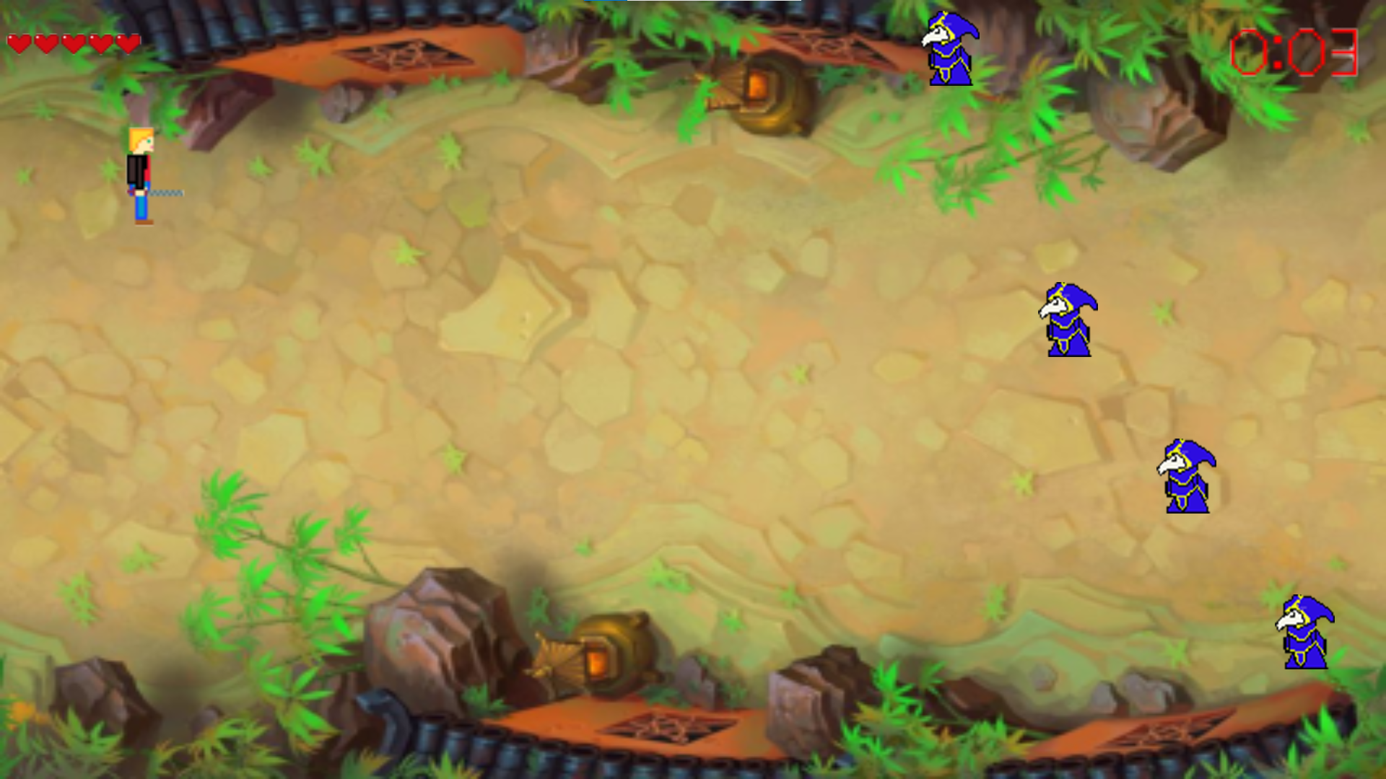INSIDE OF THE GAME:
  + Hero can move forward, upward, to left side and right side with the help of W, S, A, D keys from the keyboard.
  + When hero moves near the enemy and the user press “J” key the enemy will get killed.
* When the enemy cross the left side of the screen hero will loss a hearts/health
* When the time that is shown on the top right of the screen reaches 2:00 the game will end, and the hero will win the game.
* In the end of the game hero will either win or loss the game and points will be shown on the screen.
* END RESULT:
* 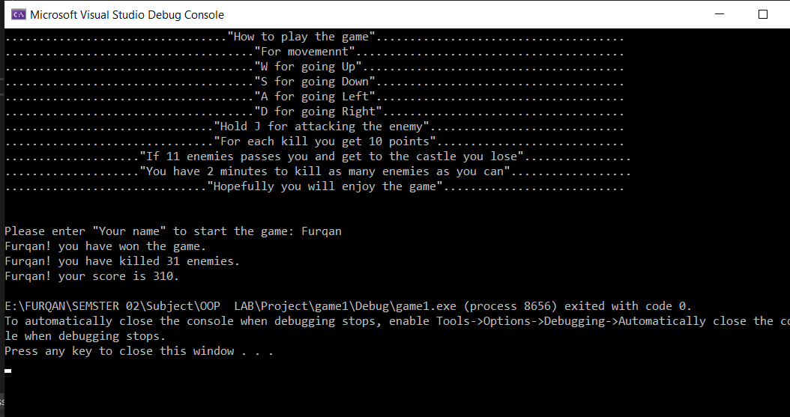 **CONCLUSION:**
  + We successfully designed a 2 D game with the help SFML and the core concepts of Object-oriented programming. Our project consists of different libraries of SFML that help us to successfully create our game.
  + Our game game has system to produces moving objects on the screen and destroy them on certain conditions we also made a health concept for our hero so that the game can have some condition in which the hero loss/win the game.
  + Whenever the user kills an enemy, he is awarded 10 points which are shown in the end of the game.
  + There is also a time limit condition which determine that the hero have won the game or has loosed it.